Virtual Workshop

Industrial Applications of
Digital Technologies

Jointly held by Technical University of Munich Asia (TUM Asia) and Center for Smart Sensing System (S³), Julong College, Shenzhen Technology University (SZTU)

Course Name: Industrial Applications of Digital Technologies

Lecturers in charge
TUM Asia: Dr. Jesmond Hong; Jesmond.hong@tum-asia.edu.sg
SZTU: Prof. Chi Chiu Chan; ccchan@sztu.edu.cn

Contact persons
TUM Asia: Dr. Jesmond Hong; Jesmond.hong@tum-asia.edu.sg
SZTU: Prof. Chi Chiu Chan; ccchan@sztu.edu.cn

Organisation:
- 4 lectures in total; 2 lectures to be held by TUM Asia; 2 lectures by SZTU
- All lectures at SZTU are online.
- Virtual workshop on 2022-03-15
- From 14:30 to 17:50 Chinese Standard Time
- Lectures will be transmitted virtually from China to Singapore and vice versa
(via Tencent and VOOV)

Learning objectives:
This virtual workshop plays a crucial role in the development of a strategic partnership between TUM Asia and SZTU utilising digital tools for synchronous learning. It sets the foundation for a joint certificate programme between both institutions.

This exchange is expected to be enriching on an academic and intercultural level. The focus is on practical-oriented methodologies, where theories and concepts that are being taught are demonstrated through case studies. It also exposes participants to real-life scenarios and applications, to help them better appreciate the value of digital solutions in advanced manufacturing. Lecturers/teachers can also incorporate these into the conception of their courses and thus convey them to their students, thereby achieving the multiplier effect.

Methods:
Lectures by TUM Asia and its industry partners; Lectures by SZTU staffs; Virtually via VOOV; Interactions with domain experts on multi-disciplinary topics.

Literature:
Information regarding the literature will be provided by the respective lecturers.

Language of Instruction:
English

Disclaimer
In an unlikely event where the designated lecturer(s) from TUM Asia is not available, TUM Asia will find a replacement to deliver the lecture(s).

Schedule on 15 March 2022

 | Chinese Standard Time | Lecturer | Topic
1 | 14:30 | Dr. Markus Wächter  (TUM Asia)  Prof. Chi Chiu Chan  (SZTU) | Opening speech by TUM Asia and SZTU
2 | 14:40 | Mr Volker Schmid  Head of Asia Pacific  Festo Didactic SE | Digital Simulation for Immersive Automation Training
3 | 15:20 | Dr Aswin Haridas  NDT Engineer  TESTIA | Inspection 4.0 for NDT and SHM
4 | 16:00 | Prof. Zidan Gong | Flexible And Soft Biosensors in Wearable Devices
5 | 16.40 | Prof. Can Yang | 3D printing of injection mold with conformal cooling channels

Speaker 1: Digital Simulation for Immersive Automation Training
(by Mr Volker Schmid, Head of Asia Pacific, Festo Didactic SE)

By its very nature of bridging the digital and physical worlds, digital twin simulation is particularly well-suited for Industry 4.0 training. Qualification for Industry 4.0 is made even easier and more stimulating when combining VR with cyber-physical systems. Not only does it allow visualisation of virtual images of the learning systems, but learners face virtual, yet full-scale equipment, real-life process and component behavior, and the ability to examine and virtually interact with equipment from different points of view to perform various tasks.

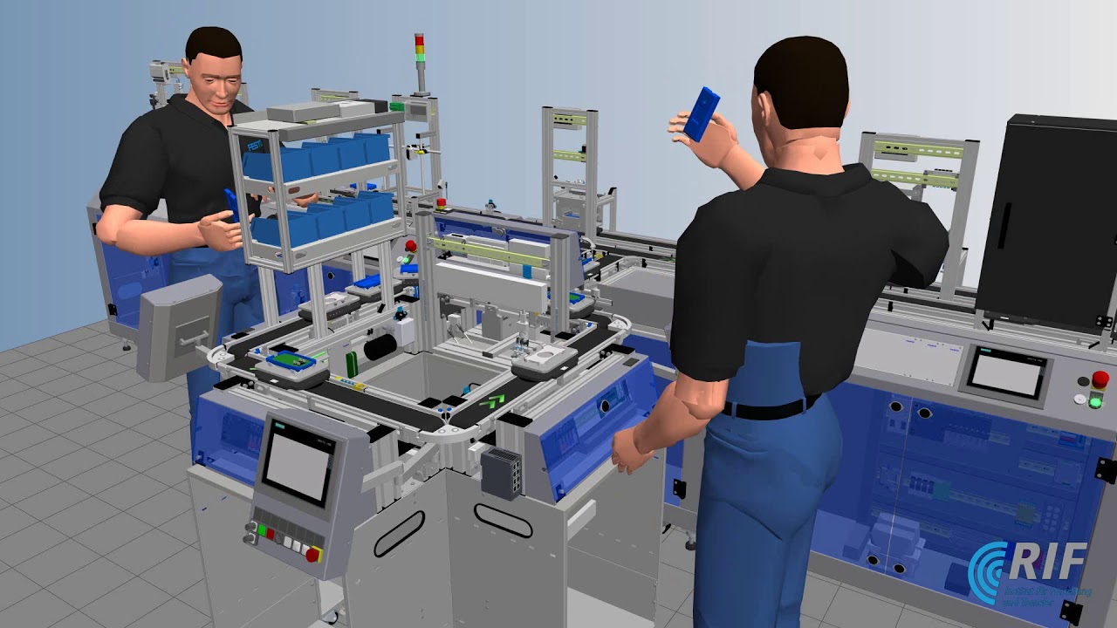

Biography
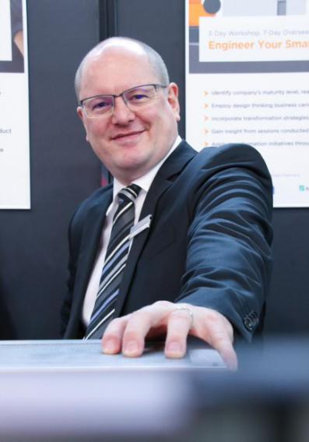
Mr. Volker Schmid, having a graduate engineering degree in Mechatronics and Automation Engineering from Esslingen University, Germany, with post graduate studies and living experiences in Singapore and Asia during the past eighteen years. He is currently holding the position of the Head of Asia and Pacific for the company of Festo Didactic SE, being the educational arm of Festo. During the past fifteen years, Mr. Schmid has been developing the educational market for Festo Didactic in Asia, Middle East and some parts of Africa, supported by various publications in the fields of curricula design, holistic approaches of training and excellence centres as well as others.

Speaker 2: Inspection 4.0 for NDT and SHM
(by Dr Aswin Haridas, TUM Alumnus)

In order to implement a robust and automated inspection process on large manufactured parts, it is necessary to measure shape irregularities at high speed, with high accuracy, while being completely impervious to the ambient light of the factory floor. Over the years, the nondestructive testing (NDT) industry continues to grow and innovate with an influx of new technologies, and as a result, the NDT job market has cracked wide open. Hear from an experienced NDT Engineer on his experience for NDT and Structure Health Monitoring (SHM) solutions in the digital age.

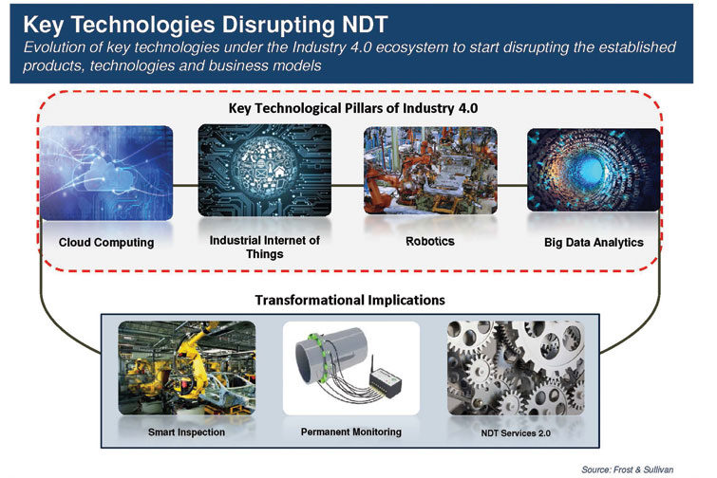

Biography
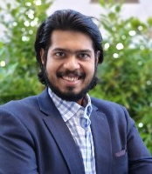
More than 6 years of R&D experience as an aerospace engineer. Worked with several world-class Aerospace and Automotive companies. Working towards Inspection 4.0. Expertise in identifying (and/or developing) Non-Destructive Testing (NDT) and Structure health Monitoring (SHM) solutions for industries including aerospace, automotive, civil and energy (among many others). Dr Aswin Haridas is a TUM Alumnus.

Speaker 3: Flexible and Soft Biosensors In Wearable Devices
(by Prof. Zidan Gong)

This lecture would mainly introduce different types of flexible and soft biosensors that could be applied in wearable devices with various purposes. For instance, fiber optic sensors, which are flexible, small-sized, lightweight, durable, cost-effective, and immune to electromagnetic interference, could be adopted to collect real-time and accurate biosignals. Biosensors developed based on Polymer substrate would fit well on the curved human body and precisely obtain the information of body movements, pressure or human-device interaction. Moreover, nanostructures could be created on Polymer substrates making self-charging sensors in a wearable system. By adopting such flexible and soft sensors in wearables, they could be widely applied in rehabilitation, physical training and even in some harsh and special working environments.

Biography

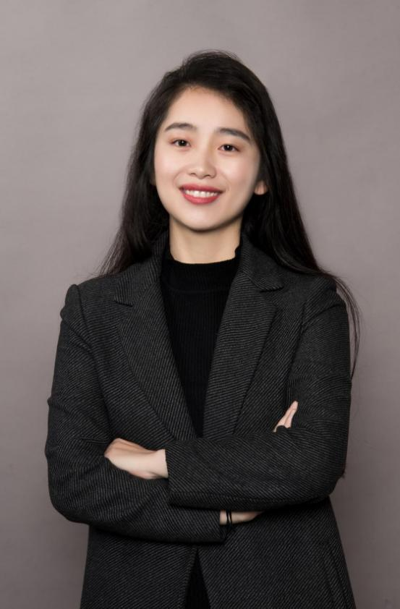

Dr. GONG Zidan
Asisstant Professor
Sino-German College of Intelligent Manufacturing, Shenzhen Technology University

Research interests
Biosensor development;
Smart textile;
Fiber optic sensors;
Wearables devices for training and rehabilitation.
Education
2015-2019:
The Hong Kong Polytechnic University; PhD; Institute of Textiles and Clothing.

2014-2015:
University of Manchester, UK;
MSc; School of Materials.

2010-2014:
Beijing Institute of Fashion Technology；B.E; School of Fashion Design and Engineering.

Speaker 4: 3D printing of injection mold with conformal cooling channels
(by Prof. Can Yang)

As a novel manufacturing approach, 3D printing (additive manufacturing) breaks through the traditional design thinking way, being able to create components with unique structures and even realize functions never fulfilled before. This lecture will start with the design concept of "what you think is what you get" of 3D printing technology, and explain the advantages of 3D printing technology and its application in various fields in recent years. A case study with 3D printing of injection mold will then be given, focusing on the model design rules as well as printing quality evaluation. Through the content of this lecture, students are expected to have better understanding of the 3D printing technology.

Biography
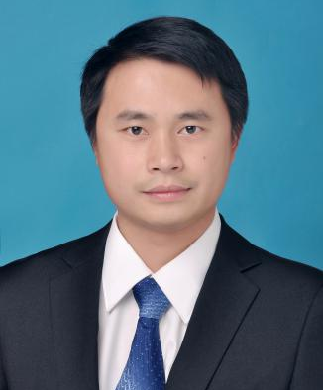  Prof. Dr. Can Yang | Dr. Can Yang received his Ph.D. degree from a joint program between South China University of Technology and Ohio State University, USA, in 2011. He is currently an Associate Professor at Shenzhen Technology University. He has 16-year research experience in precision manufacturing and additive manufacturing. He has hosted a number of national and provincial-level research projects, with systematic research on precision injection molding, polymer material morphology, and performance regulation. He has over 40 publications, 10 patents, one book chapter, and one translated work. He is a member of the American Society of Mechanical Engineers (ASME), and serves as a reviewer for several international academic journals.

