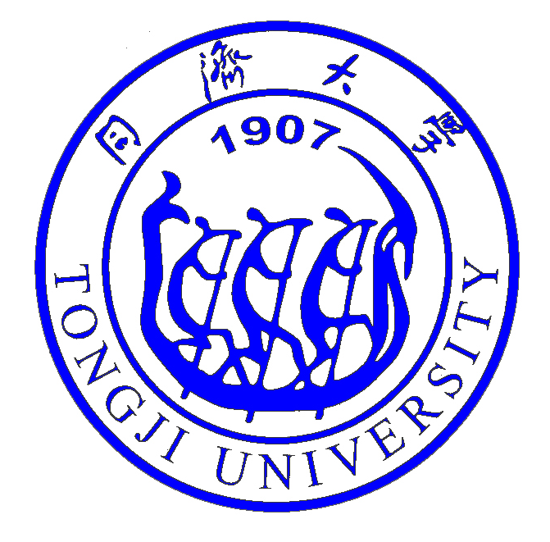

Arts et Métiers « Mobility and Transport in Digital Age »
at Tongji University
Date: October 24th, 2019
Venue: Siping Road Campus, Tongji University
Working Language: English

Program:
Times | Content | Venue
8:30-9:00 | Registration & Exchange of participants | 1st floor, Yifu Building  (Add: 1239 Siping Road)
9:00-9:30 | Opening Ceremony  - Welcome speech by Prof. JIANG Bo, Vice President of Tongji University  - Speech by Prof. Laurent CHAMPANEY, President of Arts et Métiers  - Speech by Prof. ZHONG Zaimin, Vice Dean of School of Automotive Studies of Tongji University  - Speech by Ms. CHENG Kanru, Alumni of Double Degree Program between Tongji University and Arts et Métiers | Conference Hall, 2nd floor, Yifu Building  (Add: 1239 Siping Road)
9:30-9:55 | Keynote Speech 1: The Future of Mobility powered by the 3DEXPERIENCE  by Mr. Philippe OBRY, Director Business Innovation & Transformation of Dassault Systemes
9:55-10:20 | Keynote Speech 2：Application of Virtual Reality in Automotive Manufacturing  by Mr. PENG Siwei, SYSWELD/IC.IDO Engineer of ESI
10:20-10:45 | Keynote Speech 3: Novares contribution to the Car of the Future  By Mr. Pierre Boulet, CEO of NOVARES
10:45-11:15 | Session 1: Open Lab PSA  - Open Lab PSA Strategy & Open Lab HMI at Tongji University  by Mr. Thomas Sigoigne, PSA  2) Open Lab Material and Process with Arts et Métiers  by Prof. Fodil Meraghni, Arts et Métiers
11:15-11:45 | Round Table and Q&A

